**Classroom Activity​: Write a Pattern program on Diamond**

**​Code-**

const diamondHeight = 5; // You can change this value to adjust the height of the diamond

if (diamondHeight < 1) {

console.log("Height must be a positive integer.");

} else {

// Upper part of the diamond

for (let i = 1; i <= diamondHeight; i++) {

// Print leading spaces

let spaces = ' '.repeat(diamondHeight - i);

// Print stars

let stars = '*'.repeat(2 * i - 1);

console.log(spaces + stars);

}

// Lower part of the diamond

for (let i = diamondHeight - 1; i >= 1; i--) {

// Print leading spaces

let spaces = ' '.repeat(diamondHeight - i);

// Print stars

let stars = '*'.repeat(2 * i - 1);

console.log(spaces + stars);

}

}

**Output-**

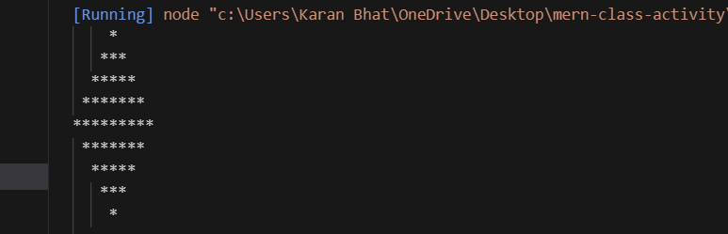

**Execution-Steps:**

* Create a JavaScript file with any name
* Write the code
* Run the code in the terminal using F5 or right click and go to inspect and you can get the output in the console as well.